**DECIMAL TO OCTAL CONVERSION**

**EXP NO: 29**

**AIM:** To write a C program to implement decimal to octal conversion.

**ALGORITHM:**  
1)      Store the remainder when the number is divided by 8 in an array.  
2)      Divide the number by 8 now  
3)      Repeat the above two steps until the number is not equal to 0.  
4)      Print the array in reverse order now.

**PROGRAM:**

#include<stdio.h>

int main()

{

long decimal, remainder, quotient,octal=0;

int octalnum[100], i = 1, j;

printf("Enter the decimal number: ");

scanf("%ld", &decimal);

quotient = decimal;

while (quotient != 0)

{

octalnum[i++] = quotient % 8;

quotient = quotient / 8;

}

for (j = i - 1; j > 0; j--)

octal= octal*10 + octalnum[j];

printf("Equivalent octal value of decimal no %d is: %d ",decimal,octalnum);

return 0;

}

**INPUT:**  
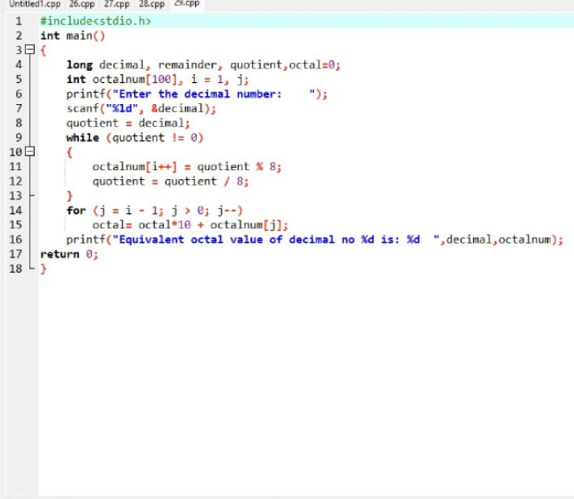  
  
**OUTPUT:**  
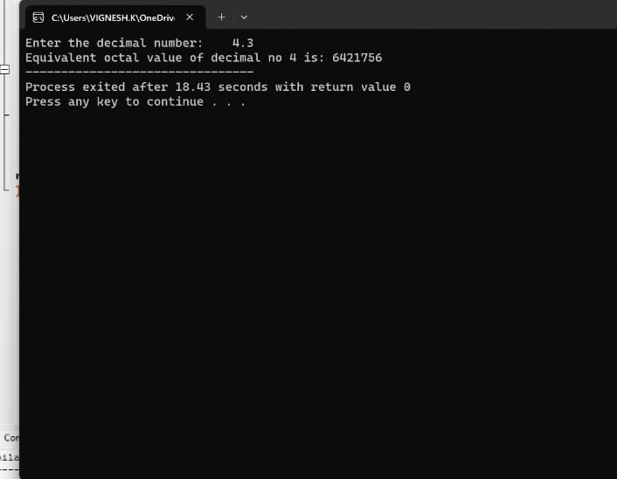

**RESULT:**

Thus the program was executed successfully using DevC++.